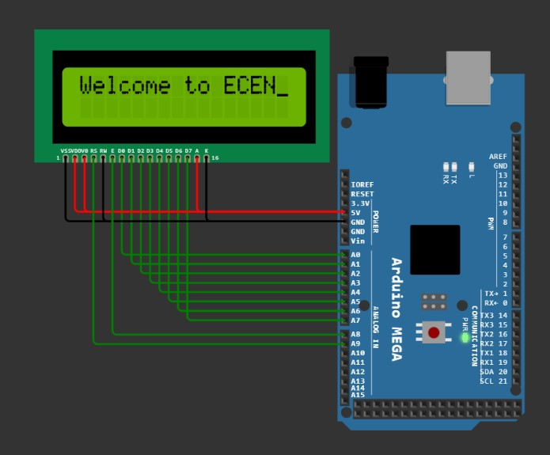
- ESP – LCD Display Programming (Lecture) :-
volatile char *dirf, *outf, *dirk, *outk;  void init_port();  void delay1(int);  void init_lcd();  void lcd_cmd(volatile char cmd);  void lcd_data(volatile char *ptr);  void setup(){  init_port();  init_lcd();  lcd_data("Welcome to ECEN");  }  void lcd_data(volatile char *ptr){  while(*ptr){  *outf=*ptr;  *outk=2; delay1(1); // rs=1; en=0;  *outk=3; delay1(1); // rs=1; en=1;  *outk=2; delay1(1); // rs=1; en=0;  ptr++;  }  }  void init_lcd(){  lcd_cmd(0x38); // 8 bit bus & 2 rows function set  lcd_cmd(0x0f); // display on, cursor blink  lcd_cmd(0x01); // clear display  lcd_cmd(0x06); // cursor auto increment  }  void lcd_cmd(volatile char cmd){  *outf=cmd;  *outk=0; delay1(1); // rs=0; en=0;  *outk=1; delay1(1); // rs=0; en=1;  *outk=0; delay1(1); // rs=0; en=0;  }  void init_port(){  dirf=0x30; *dirf=0xff;  dirk=0x107; *dirk=0x03;  outf=0x31; outk=0x108;  }  void delay1(volatile int time){  volatile long i;  while(time--) for(i=0; i<100; i++);  }  void loop() {} | 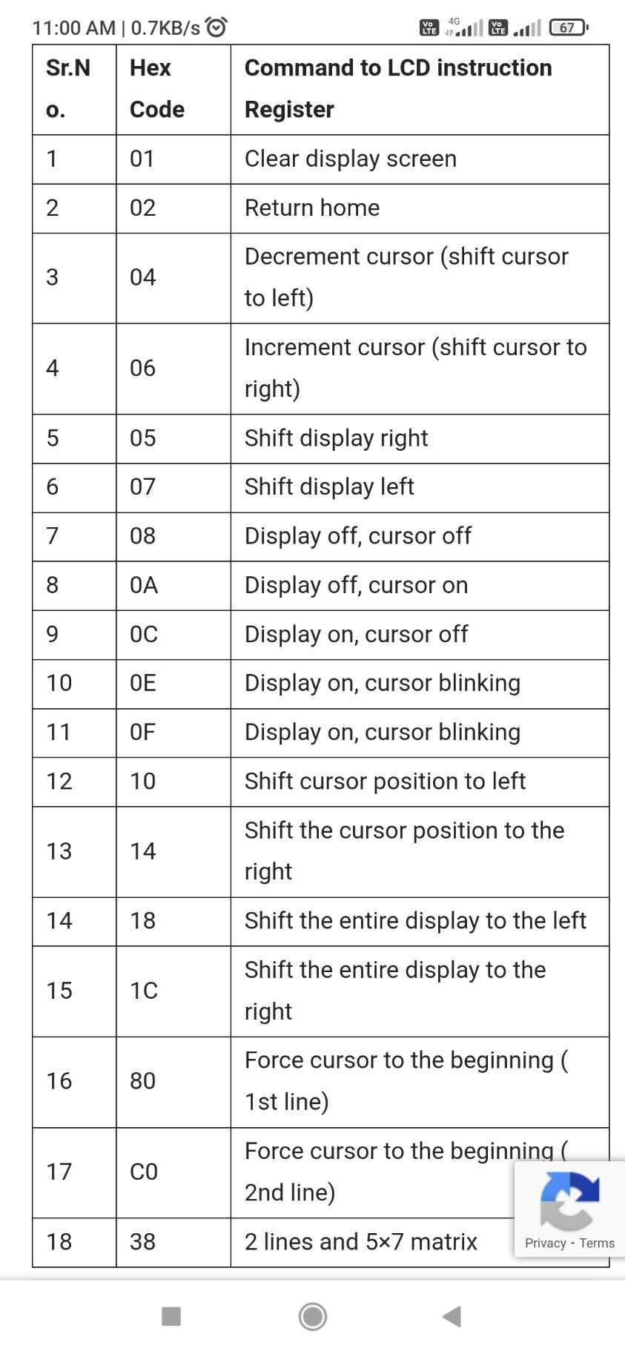

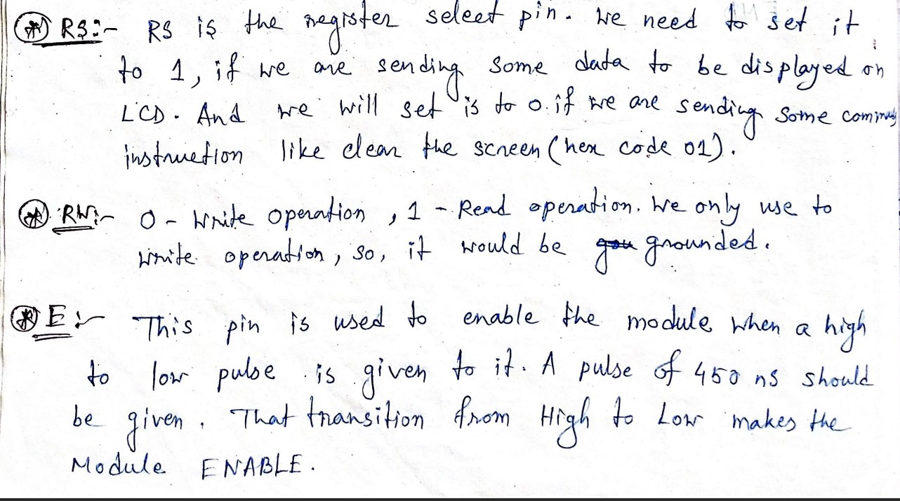
ESP – LCD Display (16 x 2) Set - 1
01 Display “Welcome" on line1. Left Justified :-  volatile char *dirf, *outf, *dirk, *outk;  void init_port();  void delay1(int);  void init_lcd();  void lcd_cmd(volatile char cmd);  void lcd_data(volatile char *ptr);  void setup(){  init_port();  init_lcd();  lcd_data("Welcome");  }  void lcd_data(volatile char *ptr){  while(*ptr){  *outf=*ptr;  *outk=2; delay1(1); // rs=1; en=0;  *outk=3; delay1(1); // rs=1; en=1;  *outk=2; delay1(1); // rs=1; en=0;  ptr++;  }  }  void init_lcd(){  lcd_cmd(0x38); // 8 bit bus & 2 rows function set  lcd_cmd(0x0f); // display on, cursor blink  lcd_cmd(0x01); // clear display  lcd_cmd(0x06); // cursor auto increment  }  void lcd_cmd(volatile char cmd){  *outf=cmd;  *outk=0; delay1(1); // rs=0; en=0;  *outk=1; delay1(1); // rs=0; en=1;  *outk=0; delay1(1); // rs=0; en=0;  }  void init_port(){  dirf=0x30; *dirf=0xff;  dirk=0x107; *dirk=0x03;  outf=0x31; outk=0x108;  }  void delay1(volatile int time){  volatile long i;  while(time--) for(i=0; i<100; i++);  }  void loop() {} | 02 Display “Welcome” on line1. Right Justified:-  volatile char *dirf, *outf, *dirk, *outk;  void init_port();  void delay1(int);  void init_lcd();  void lcd_cmd(volatile char cmd);  void lcd_data(volatile char *ptr);  void setup(){  init_port();  init_lcd();  lcd_data("Welcome");  }  void lcd_data(volatile char *ptr){  while(*ptr){  *outf=*ptr;  *outk=2; delay1(1); // rs=1; en=0;  *outk=3; delay1(1); // rs=1; en=1;  *outk=2; delay1(1); // rs=1; en=0;  ptr++;  }  }  void init_lcd(){  lcd_cmd(0x38); // 8 bit bus & 2 rows function set  lcd_cmd(0x0f); // display on, cursor blink  lcd_cmd(0x01); // clear display  lcd_cmd(0x06); // cursor auto increment  lcd_cmd(0x89); // set cursor to row 0 col 9  }  void lcd_cmd(volatile char cmd){  *outf=cmd;  *outk=0; delay1(1); // rs=0; en=0;  *outk=1; delay1(1); // rs=0; en=1;  *outk=0; delay1(1); // rs=0; en=0;  }  void init_port(){  dirf=0x30; *dirf=0xff;  dirk=0x107; *dirk=0x03;  outf=0x31; outk=0x108;  }  void delay1(volatile int time){  volatile long i;  while(time--) for(i=0; i<100; i++);  }  void loop() {}
03 Display “Welcome" on line1. Middle :-  volatile char *dirf, *outf, *dirk, *outk;  void init_port();  void delay1(int);  void init_lcd();  void lcd_cmd(volatile char cmd);  void lcd_data(volatile char *ptr);  void setup(){  init_port();  init_lcd();  lcd_data("Welcome");  }  void lcd_data(volatile char *ptr){  while(*ptr){  *outf=*ptr;  *outk=2; delay1(1); // rs=1; en=0;  *outk=3; delay1(1); // rs=1; en=1;  *outk=2; delay1(1); // rs=1; en=0;  ptr++;  }  }  void init_lcd(){  lcd_cmd(0x38); // 8 bit bus & 2 rows function set  lcd_cmd(0x0f); // display on, cursor blink  lcd_cmd(0x01); // clear display  lcd_cmd(0x06); // cursor auto increment  lcd_cmd(0x84); // set cursor to row 0 col 4  }  void lcd_cmd(volatile char cmd){  *outf=cmd;  *outk=0; delay1(1); // rs=0; en=0;  *outk=1; delay1(1); // rs=0; en=1;  *outk=0; delay1(1); // rs=0; en=0;  }  void init_port(){  dirf=0x30; *dirf=0xff;  dirk=0x107; *dirk=0x03;  outf=0x31; outk=0x108;  }  void delay1(volatile int time){  volatile long i;  while(time--) for(i=0; i<100; i++);  }  void loop() {} | 04 Display “Welcome" on line2. Left Justified :-  volatile char *dirf, *outf, *dirk, *outk;  void init_port();  void delay1(int);  void init_lcd();  void lcd_cmd(volatile char cmd);  void lcd_data(volatile char *ptr);  void setup(){  init_port();  init_lcd();  lcd_data("Welcome");  }  void lcd_data(volatile char *ptr){  while(*ptr){  *outf=*ptr;  *outk=2; delay1(1); // rs=1; en=0;  *outk=3; delay1(1); // rs=1; en=1;  *outk=2; delay1(1); // rs=1; en=0;  ptr++;  }  }  void init_lcd(){  lcd_cmd(0x38); // 8 bit bus & 2 rows function set  lcd_cmd(0x0f); // display on, cursor blink  lcd_cmd(0x01); // clear display  lcd_cmd(0x06); // cursor auto increment  lcd_cmd(0xc0); // set cursor to row 1 col 0  }  void lcd_cmd(volatile char cmd){  *outf=cmd;  *outk=0; delay1(1); // rs=0; en=0;  *outk=1; delay1(1); // rs=0; en=1;  *outk=0; delay1(1); // rs=0; en=0;  }  void init_port(){  dirf=0x30; *dirf=0xff;  dirk=0x107; *dirk=0x03;  outf=0x31; outk=0x108;  }  void delay1(volatile int time){  volatile long i;  while(time--) for(i=0; i<100; i++);  }  void loop() {}

05 Display “Welcome" on line2. Right Justified:-  volatile char *dirf, *outf, *dirk, *outk;  void init_port();  void delay1(int);  void init_lcd();  void lcd_cmd(volatile char cmd);  void lcd_data(volatile char *ptr);  void setup(){  init_port();  init_lcd();  lcd_data("Welcome");  }  void lcd_data(volatile char *ptr){  while(*ptr){  *outf=*ptr;  *outk=2; delay1(1); // rs=1; en=0;  *outk=3; delay1(1); // rs=1; en=1;  *outk=2; delay1(1); // rs=1; en=0;  ptr++;  }  }  void init_lcd(){  lcd_cmd(0x38); // 8 bit bus & 2 rows function set  lcd_cmd(0x0f); // display on, cursor blink  lcd_cmd(0x01); // clear display  lcd_cmd(0x06); // cursor auto increment  lcd_cmd(0xc9); // set cursor to row 1 col 9  }  void lcd_cmd(volatile char cmd){  *outf=cmd;  *outk=0; delay1(1); // rs=0; en=0;  *outk=1; delay1(1); // rs=0; en=1;  *outk=0; delay1(1); // rs=0; en=0;  }  void init_port(){  dirf=0x30; *dirf=0xff;  dirk=0x107; *dirk=0x03;  outf=0x31; outk=0x108;  }  void delay1(volatile int time){  volatile long i;  while(time--) for(i=0; i<100; i++);  }  void loop() {} | 06 Display “Welcome" on line2. Middle :-  volatile char *dirf, *outf, *dirk, *outk;  void init_port();  void delay1(int);  void init_lcd();  void lcd_cmd(volatile char cmd);  void lcd_data(volatile char *ptr);  void setup(){  init_port();  init_lcd();  lcd_data("Welcome");  }  void lcd_data(volatile char *ptr){  while(*ptr){  *outf=*ptr;  *outk=2; delay1(1); // rs=1; en=0;  *outk=3; delay1(1); // rs=1; en=1;  *outk=2; delay1(1); // rs=1; en=0;  ptr++;  }  }  void init_lcd(){  lcd_cmd(0x38); // 8 bit bus & 2 rows function set  lcd_cmd(0x0f); // display on, cursor blink  lcd_cmd(0x01); // clear display  lcd_cmd(0x06); // cursor auto increment  lcd_cmd(0xc4); // set cursor to row 1 col 4  }  void lcd_cmd(volatile char cmd){  *outf=cmd;  *outk=0; delay1(1); // rs=0; en=0;  *outk=1; delay1(1); // rs=0; en=1;  *outk=0; delay1(1); // rs=0; en=0;  }  void init_port(){  dirf=0x30; *dirf=0xff;  dirk=0x107; *dirk=0x03;  outf=0x31; outk=0x108;  }  void delay1(volatile int time){  volatile long i;  while(time--) for(i=0; i<100; i++);  }  void loop() {}
07 Display “Welcome" on line1. Middle & Display “To ECEN Academy” on line2 Middle :-  volatile char *dirf, *outf, *dirk, *outk;  void init_port();  void delay1(int);  void init_lcd();  void lcd_cmd(volatile char cmd);  void lcd_data(volatile char *ptr);  void setup(){  init_port();  init_lcd();  lcd_cmd(0x84); // set cursor to row 0 col 4  lcd_data("Welcome");  lcd_cmd(0xc0); // set cursor to row 1 col 0  lcd_data("to ECEN Academy");  }  void lcd_data(volatile char *ptr){  while(*ptr){  *outf=*ptr;  *outk=2; delay1(1); // rs=1; en=0;  *outk=3; delay1(1); // rs=1; en=1;  *outk=2; delay1(1); // rs=1; en=0;  ptr++;  }  }  void init_lcd(){  lcd_cmd(0x38); // 8 bit bus & 2 rows function set  lcd_cmd(0x0f); // display on, cursor blink  lcd_cmd(0x01); // clear display  }  void lcd_cmd(volatile char cmd){  *outf=cmd;  *outk=0; delay1(1); // rs=0; en=0;  *outk=1; delay1(1); // rs=0; en=1;  *outk=0; delay1(1); // rs=0; en=0;  }  void init_port(){  dirf=0x30; *dirf=0xff;  dirk=0x107; *dirk=0x03;  outf=0x31; outk=0x108;  }  void delay1(volatile int time){  volatile long i;  while(time--) for(i=0; i<100; i++);  }  void loop() {} | 08 Display “Welcome” on line1. Enter from Right. Left Justified :-  volatile char *dirf, *outf, *dirk, *outk;  void init_port();  void delay1(int);  void init_lcd();  void lcd_cmd(volatile char cmd);  void lcd_data(volatile char *ptr);  void setup(){  volatile short a;  volatile long i;  init_port();  init_lcd();  for(a=0x8f; a>=0x80; a--){  lcd_cmd(0x01);  lcd_cmd(a);  lcd_data("Welcome");  for(i=0; i<100000; i++);  }  }  void lcd_data(volatile char *ptr){  while(*ptr){  *outf=*ptr;  *outk=2; delay1(1); // rs=1; en=0;  *outk=3; delay1(1); // rs=1; en=1;  *outk=2; delay1(1); // rs=1; en=0;  ptr++;  }  }  void init_lcd(){  lcd_cmd(0x38); // 8 bit bus & 2 rows function set  lcd_cmd(0x0f); // display on, cursor blink  lcd_cmd(0x01); // clear display  }  void lcd_cmd(volatile char cmd){  *outf=cmd;  *outk=0; delay1(1); // rs=0; en=0;  *outk=1; delay1(1); // rs=0; en=1;  *outk=0; delay1(1); // rs=0; en=0;  }  void init_port(){  dirf=0x30; *dirf=0xff;  dirk=0x107; *dirk=0x03;  outf=0x31; outk=0x108;  }  void delay1(volatile int time){  volatile long i;  while(time--) for(i=0; i<100; i++);  }  void loop() {}
09 Display “Welcome” on line2. Enter from Left. Right Justified :-  volatile char *dirf, *outf, *dirk, *outk;  void init_port();  void delay1(int);  void init_lcd();  void lcd_cmd(volatile char cmd);  void lcd_data(volatile char *ptr);  void setup(){  volatile short a;  volatile long i;  init_port();  init_lcd();  for(a=0xb9; a<=0xc9; a++){  lcd_cmd(0x01);  lcd_cmd(a);  lcd_data("Welcome");  for(i=0; i<100000; i++);  }  }  void lcd_data(volatile char *ptr){  while(*ptr){  *outf=*ptr;  *outk=2; delay1(1); // rs=1; en=0;  *outk=3; delay1(1); // rs=1; en=1;  *outk=2; delay1(1); // rs=1; en=0;  ptr++;  }  }  void init_lcd(){  lcd_cmd(0x38); // 8 bit bus & 2 rows function set  lcd_cmd(0x0f); // display on, cursor blink  lcd_cmd(0x01); // clear display  }  void lcd_cmd(volatile char cmd){  *outf=cmd;  *outk=0; delay1(1); // rs=0; en=0;  *outk=1; delay1(1); // rs=0; en=1;  *outk=0; delay1(1); // rs=0; en=0;  }  void init_port(){  dirf=0x30; *dirf=0xff;  dirk=0x107; *dirk=0x03;  outf=0x31; outk=0x108;  }  void delay1(volatile int time){  volatile long i;  while(time--) for(i=0; i<100; i++);  }  void loop() {} | 10 Display “Welcome” on Line 1. Enter from Left to Middle. Display “To ECEN Academy” on Line2 Enter from Right to Middle :-  volatile char *dirf, *outf, *dirk, *outk;  void init_port();  void delay1(int);  void init_lcd();  void lcd_cmd(volatile char cmd);  void lcd_data(volatile char *ptr);  void setup(){  volatile short a;  volatile long i;  init_port(); init_lcd();  for(a=0x80; a<0x8c; a++){  lcd_cmd(0x01);  lcd_cmd(0x04); // for left shift the cursor;  lcd_cmd(a);  lcd_data("emocleW");  for(i=0; i<100000; i++);  }  for(a=0xd0; a>=0xc1; a--){  lcd_cmd(0x01);  lcd_cmd(0x85);  lcd_data("Welcome");  lcd_cmd(a);  lcd_data("To ECEN Academy");  for(i=0; i<100000; i++);  } }  void lcd_data(volatile char *ptr){  while(*ptr){  *outf=*ptr; *outk=2; delay1(1);  *outk=3; delay1(1); *outk=2; delay1(1);  ptr++;  } }  void init_lcd(){  lcd_cmd(0x38); lcd_cmd(0x0f); lcd_cmd(0x01);  }  void lcd_cmd(volatile char cmd){  *outf=cmd; *outk=0; delay1(1);  *outk=1; delay1(1); *outk=0; delay1(1);  }  void init_port(){  dirf=0x30; *dirf=0xff;  dirk=0x107; *dirk=0x03;  outf=0x31; outk=0x108;  }  void delay1(volatile int time){  volatile long i;  while(time--) for(i=0; i<100; i++);  }  void loop() {}
ESP – LCD Display (16 x 2) Set - 2
01 Display “Welcome to" on line1. Rotate left to right continuously :-  volatile char *dirf, *outf, *dirk, *outk;  void init_port();  void delay1(int);  void init_lcd();  void lcd_cmd(volatile char cmd);  void lcd_data(volatile char *ptr);  void setup(){  volatile char a;  volatile long i;  init_port();  init_lcd();  while(1){  lcd_cmd(0x0a); // Display off cursor on  lcd_data("Welcome To");  lcd_cmd(0x0c); // Display on cursor off  // shifting entire display left 10 position  for(a=0; a<10; a++) lcd_cmd(0x18);  for(a=0; a<25; a++){  lcd_cmd(0x1c);  for(i=0; i<100000; i++);  }  lcd_cmd(0x01);  } }  void lcd_data(volatile char *ptr){  while(*ptr){  *outf=*ptr; *outk=2; delay1(1); // rs=1; en=0;  *outk=3; delay1(1); *outk=2; delay1(1);  ptr++;  } }  void init_lcd(){  lcd_cmd(0x38); // 8 bit bus & 2 rows function set  lcd_cmd(0x0f); // display on, cursor blink  lcd_cmd(0x01); // clear display  }  void lcd_cmd(volatile char cmd){  *outf=cmd; *outk=0; delay1(1); // rs=0; en=0;  *outk=1; delay1(1); *outk=0; delay1(1);  }  void init_port(){  dirf=0x30; *dirf=0xff; dirk=0x107; *dirk=0x03;  outf=0x31; outk=0x108;  }  void delay1(volatile int time){  volatile long i;  while(time--) for(i=0; i<100; i++);  }  void loop() {} | 02 Display “Welcome to" on line1. Rotate right to left continuously :-  volatile char *dirf, *outf, *dirk, *outk;  void init_port();  void delay1(int);  void init_lcd();  void lcd_cmd(volatile char cmd);  void lcd_data(volatile char *ptr);  void setup(){  volatile char a;  volatile long i;  init_port();  init_lcd();  while(1){  lcd_cmd(0x0a); // Display off cursor on  lcd_cmd(0x91);  lcd_data("Welcome To");  lcd_cmd(0x0c); // Display on cursor off  for(a=0; a<25; a++){  lcd_cmd(0x18);  for(i=0; i<100000; i++);  }  lcd_cmd(0x01);  } }  void lcd_data(volatile char *ptr){  while(*ptr){  *outf=*ptr; *outk=2; delay1(1); // rs=1; en=0;  *outk=3; delay1(1); *outk=2; delay1(1);  ptr++;  } }  void init_lcd(){  lcd_cmd(0x38); // 8 bit bus & 2 rows function set  lcd_cmd(0x0f); // display on, cursor blink  lcd_cmd(0x01); // clear display  }  void lcd_cmd(volatile char cmd){  *outf=cmd; *outk=0; delay1(1); // rs=0; en=0;  *outk=1; delay1(1); *outk=0; delay1(1);  }  void init_port(){  dirf=0x30; *dirf=0xff; dirk=0x107; *dirk=0x03;  outf=0x31; outk=0x108;  }  void delay1(volatile int time){  volatile long i;  while(time--) for(i=0; i<100; i++);  }  void loop() {}
03 Display “ECEN Academy" on line2. Rotate left to right continuously :-  volatile char *dirf, *outf, *dirk, *outk;  void init_port();  void delay1(int);  void init_lcd();  void lcd_cmd(volatile char cmd);  void lcd_data(volatile char *ptr);  void setup(){  volatile char a;  volatile long i;  init_port();  init_lcd();  while(1){  lcd_cmd(0x0a); // Display off cursor on  lcd_cmd(0xc0);  lcd_data("ECEN Academy");  // shifting entire display left 10 position  for(a=0; a<12; a++) lcd_cmd(0x18);  lcd_cmd(0x0c); // Display on cursor off  for(a=0; a<29; a++){  lcd_cmd(0x1c);  for(i=0; i<100000; i++);  }  lcd_cmd(1);  } }  void lcd_data(volatile char *ptr){  while(*ptr){  *outf=*ptr; *outk=2; delay1(1); // rs=1; en=0;  *outk=3; delay1(1); *outk=2; delay1(1);  ptr++;  } }  void init_lcd(){  lcd_cmd(0x38); // 8 bit bus & 2 rows function set  lcd_cmd(0x0f); // display on, cursor blink  lcd_cmd(0x01); // clear display  }  void lcd_cmd(volatile char cmd){  *outf=cmd; *outk=0; delay1(1); // rs=0; en=0;  *outk=1; delay1(1); *outk=0; delay1(1);  }  void init_port(){  dirf=0x30; *dirf=0xff; dirk=0x107; *dirk=0x03;  outf=0x31; outk=0x108;  }  void delay1(volatile int time){  volatile long i;  while(time--) for(i=0; i<100; i++);  }  void loop() {} | 04 Display “ECEN Academy" on line2. Rotate right to left continuously :-  volatile char *dirf, *outf, *dirk, *outk;  void init_port();  void delay1(int);  void init_lcd();  void lcd_cmd(volatile char cmd);  void lcd_data(volatile char *ptr);  void setup(){  volatile char a;  volatile long i;  init_port();  init_lcd();  while(1){  lcd_cmd(0x0a); // Display off cursor on  lcd_cmd(0xd1);  lcd_data("ECEN Academy");  lcd_cmd(0x0c); // Display on cursor off  for(a=0; a<29; a++){  lcd_cmd(0x18);  for(i=0; i<100000; i++);  }  lcd_cmd(0x01);  } }  void lcd_data(volatile char *ptr){  while(*ptr){  *outf=*ptr; *outk=2; delay1(1); // rs=1; en=0;  *outk=3; delay1(1); *outk=2; delay1(1);  ptr++;  } }  void init_lcd(){  lcd_cmd(0x38); // 8 bit bus & 2 rows function set  lcd_cmd(0x0f); // display on, cursor blink  lcd_cmd(0x01); // clear display  }  void lcd_cmd(volatile char cmd){  *outf=cmd; *outk=0; delay1(1); // rs=0; en=0;  *outk=1; delay1(1); *outk=0; delay1(1);  }  void init_port(){  dirf=0x30; *dirf=0xff; dirk=0x107; *dirk=0x03;  outf=0x31; outk=0x108;  }  void delay1(volatile int time){  volatile long i;  while(time--) for(i=0; i<100; i++);  }  void loop() {}
05 Display “Welcome to" on line1 in middle and “ECEN Academy” on line2. Rotate line2 right to left continuously :-  volatile char *dirf, *outf, *dirk, *outk;  void init_port();  void delay1(int);  void init_lcd();  void lcd_cmd(volatile char cmd);  void lcd_data(volatile char *ptr);  void setup(){  volatile short a;  volatile long i;  init_port(); init_lcd();  while(1){  for(a=0xd0; a>=0xb5; a--){  lcd_cmd(0x01);  lcd_cmd(0x83);  lcd_data("Welcome To");  lcd_cmd(a);  lcd_data("ECEN Academy");  for(i=0; i<100000; i++);  } } }  void lcd_data(volatile char *ptr){  while(*ptr){  *outf=*ptr; *outk=2; delay1(1);  *outk=3; delay1(1); *outk=2; delay1(1);  ptr++;  } }  void init_lcd(){  lcd_cmd(0x38); lcd_cmd(0x0c); lcd_cmd(0x01);  }  void lcd_cmd(volatile char cmd){  *outf=cmd;  *outk=0; delay1(1);  *outk=1; delay1(1);  *outk=0; delay1(1);  }  void init_port(){  dirf=0x30; *dirf=0xff;  dirk=0x107; *dirk=0x03;  outf=0x31; outk=0x108;  }  void delay1(volatile int time){  volatile long i;  while(time--) for(i=0; i<100; i++);  }  void loop() {} | 06 Display “Welcome to" on line1. Rotate line1 right to left Continuously and “ECEN Academy” on line2 in Middle :-  volatile char *dirf, *outf, *dirk, *outk;  void init_port();  void delay1(int);  void init_lcd();  void lcd_cmd(volatile char cmd);  void lcd_data(volatile char *ptr);  void setup(){  volatile short a;  volatile long i;  init_port(); init_lcd();  while(1){  for(a=0x9a; a>=0x80; a--){  lcd_cmd(0x01);  lcd_cmd(0x04); // for left shift the cursor;  lcd_cmd(a);  lcd_data("oT emocleW");  lcd_cmd(0xcd);  lcd_data("ymedacA NECE");  for(i=0; i<100000; i++);  } } }  void lcd_data(volatile char *ptr){  while(*ptr){  *outf=*ptr; *outk=2; delay1(1);  *outk=3; delay1(1); *outk=2; delay1(1);  ptr++;  } }  void init_lcd(){  lcd_cmd(0x38); lcd_cmd(0x0c); lcd_cmd(0x01);  }  void lcd_cmd(volatile char cmd){  *outf=cmd;  *outk=0; delay1(1);  *outk=1; delay1(1);  *outk=0; delay1(1);  }  void init_port(){  dirf=0x30; *dirf=0xff;  dirk=0x107; *dirk=0x03;  outf=0x31; outk=0x108;  }  void delay1(volatile int time){  volatile long i;  while(time--) for(i=0; i<100; i++);  }  void loop() {}

07 Display “Welcome to" on line1 in middle. “ECEN Academy” on line2 and rotate line2 left to right continuously :-  volatile char *dirf, *outf, *dirk, *outk;  void init_port();  void delay1(int);  void init_lcd();  void lcd_cmd(volatile char cmd);  void lcd_data(volatile char *ptr);  void setup(){  volatile short a;  volatile long i;  init_port(); init_lcd();  while(1){  for(a=0xc0; a<=0xdb; a++){  lcd_cmd(0x01);  lcd_cmd(0x83);  lcd_data("Welcome To");  lcd_cmd(0x04); // for left shift the cursor;  lcd_cmd(a);  lcd_data("ymedacA NECE");  for(i=0; i<100000; i++);  } } }  void lcd_data(volatile char *ptr){  while(*ptr){  *outf=*ptr; *outk=2; delay1(1);  *outk=3; delay1(1); *outk=2; delay1(1);  ptr++;  } }  void init_lcd(){  lcd_cmd(0x38); lcd_cmd(0x0c); lcd_cmd(0x01);  }  void lcd_cmd(volatile char cmd){  *outf=cmd;  *outk=0; delay1(1);  *outk=1; delay1(1);  *outk=0; delay1(1);  }  void init_port(){  dirf=0x30; *dirf=0xff;  dirk=0x107; *dirk=0x03;  outf=0x31; outk=0x108;  }  void delay1(volatile int time){  volatile long i;  while(time--) for(i=0; i<100; i++);  }  void loop() {} | 08 Display “Welcome to" on line1. Rotate line1 left to right Continuously and “ECEN Academy” on line2 in Middle :-  volatile char *dirf, *outf, *dirk, *outk;  void init_port();  void delay1(int);  void init_lcd();  void lcd_cmd(volatile char cmd);  void lcd_data(volatile char *ptr);  void setup(){  volatile short a;  volatile long i;  init_port(); init_lcd();  while(1){  for(a=0x80; a<=0x9b; a++){  lcd_cmd(0x01);  lcd_cmd(0x04); // for left shift the cursor;  lcd_cmd(a);  lcd_data("oT emocleW");  lcd_cmd(0x06); // for right shift the cursor  lcd_cmd(0xc2);  lcd_data("ECEN Academy");  for(i=0; i<100000; i++);  } } }  void lcd_data(volatile char *ptr){  while(*ptr){  *outf=*ptr; *outk=2; delay1(1);  *outk=3; delay1(1); *outk=2; delay1(1);  ptr++;  } }  void init_lcd(){  lcd_cmd(0x38); lcd_cmd(0x0c); lcd_cmd(0x01);  }  void lcd_cmd(volatile char cmd){  *outf=cmd;  *outk=0; delay1(1);  *outk=1; delay1(1);  *outk=0; delay1(1);  }  void init_port(){  dirf=0x30; *dirf=0xff;  dirk=0x107; *dirk=0x03;  outf=0x31; outk=0x108;  }  void delay1(volatile int time){  volatile long i;  while(time--) for(i=0; i<100; i++);  }  void loop() {}
09 Display “Welcome to" on line1. Rotate right to left continuously. “ECEN Academy" on line2. Rotate left to right continuously :-  volatile char *dirf, *outf, *dirk, *outk;  void init_port();  void delay1(int);  void init_lcd();  void lcd_cmd(volatile char cmd);  void lcd_data(volatile char *ptr);  void setup(){  volatile short a, b;  volatile long i;  init_port(); init_lcd();  while(1){  for(a=0x9a, b=0xc0; a>=0x80; a--, b++){  lcd_cmd(0x01);  lcd_cmd(0x04); // for left shift the cursor;  lcd_cmd(a);  lcd_data("oT emocleW");  lcd_cmd(0x04); // for left shift the cursor;  lcd_cmd(b);  lcd_data("ymedacA NECE");  for(i=0; i<100000; i++);  } } }  void lcd_data(volatile char *ptr){  while(*ptr){  *outf=*ptr; *outk=2; delay1(1);  *outk=3; delay1(1); *outk=2; delay1(1);  ptr++;  } }  void init_lcd(){  lcd_cmd(0x38); lcd_cmd(0x0c); lcd_cmd(0x01);  }  void lcd_cmd(volatile char cmd){  *outf=cmd;  *outk=0; delay1(1);  *outk=1; delay1(1);  *outk=0; delay1(1);  }  void init_port(){  dirf=0x30; *dirf=0xff;  dirk=0x107; *dirk=0x03;  outf=0x31; outk=0x108;  }  void delay1(volatile int time){  volatile long i;  while(time--) for(i=0; i<100; i++);  }  void loop() {} | 10 Display “Welcome to" on line1. Rotate left to right continuously. “ECEN Academy" on line2. Rotate right to left continuously :-  volatile char *dirf, *outf, *dirk, *outk;  void init_port();  void delay1(int);  void init_lcd();  void lcd_cmd(volatile char cmd);  void lcd_data(volatile char *ptr);  void setup(){  volatile short a, b;  volatile long i;  init_port(); init_lcd();  while(1){  for(a=0x80, b=0xda; a<=0x9b; a++, b--){  lcd_cmd(0x01);  lcd_cmd(0x04); // for left shift the cursor;  lcd_cmd(a);  lcd_data("oT emocleW");  lcd_cmd(b);  lcd_data("ymedacA NECE");  for(i=0; i<100000; i++);  } } }  void lcd_data(volatile char *ptr){  while(*ptr){  *outf=*ptr; *outk=2; delay1(1);  *outk=3; delay1(1); *outk=2; delay1(1);  ptr++;  } }  void init_lcd(){  lcd_cmd(0x38); lcd_cmd(0x0c); lcd_cmd(0x01);  }  void lcd_cmd(volatile char cmd){  *outf=cmd;  *outk=0; delay1(1);  *outk=1; delay1(1);  *outk=0; delay1(1);  }  void init_port(){  dirf=0x30; *dirf=0xff;  dirk=0x107; *dirk=0x03;  outf=0x31; outk=0x108;  }  void delay1(volatile int time){  volatile long i;  while(time--) for(i=0; i<100; i++);  }  void loop() {}

